RESOLUTION NO.__________

RE: CERTIFICATE OF APPROPRIATENESS UNDER THE
PROVISIONS OF THE ACT OF THE PENNSYLVANIA
LEGISLATURE 1961, JUNE 13, P.L. 282 (53
SECTION 8004) AND BETHLEHEM ORDINANCE NO.
3952 AS AMENDED.

WHEREAS, it is proposed to install signs at 126-128 E 3rd St.

NOW, THEREFORE, BE IT RESOLVED by the Council of the City of Bethlehem that a Certificate of Appropriateness is hereby granted for the work.

Sponsored by: (s)

(s)

ADOPTED BY COUNCIL THIS DAY OF

(s)
President of Council

ATTEST:

(s)
City Clerk

HISTORIC CONSERVATION COMMISSION

CASE # 445 – It is proposed to install signs at 126-128 E 3rd St.
OWNER/APPLICANT: Gotham House, LP / KHS Bethlehem Inc.

The Commission upon motion by Mr. Cornish seconded by Mr. Evans adopted the proposal that City Council issue a Certificate of Appropriateness for the proposed work described herein:

- The proposal to install signs at 126-128 E 3rd St. was presented by Jason Harris & Judy Parsons.

- Signs #1, 2, & 4 will read “Keystone Homebrew Supplies, Make Your Own Beer & Wine” with the web address and telephone number on a brown background with “Keystone Homebrew Supplies” in blue lettering within logo. “Make Your Own Beer & Wine” and the telephone number will be in white lettering. The web address will be in brown lettering on a yellow band 1/3 way down the sign. The signs will also have a yellow pinstripe border.

- Sign #1 will be a 4’x 8’ sign located above the front door and window area of the building

- Sign #2 will be a 4’x 16’ sign located high on the parking lot side of building

- Sign #3 will be a 5’x 8’ sign located below Sign #2 on the parking lot side of building and will read “classes, steins, wine gifts, barware, draft beer supplies” in white lettering on a brown background with a yellow pinstripe border.

- Sign #4 will be a 4’x14’ sign located on the Webster Street side of building

- Sign #5 will be a 1’x 2’ sign located on the rear of the building and will read: “Keystone Homebrew Supplies, Entrance on 3rd St.” in brown lettering on a white background.

- The proposed motion was unanimously approved.

CU: cu

By: 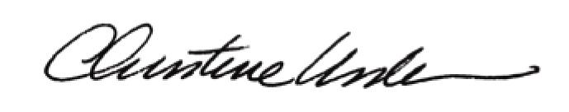

Date of Meeting: April 15, 2013 Title: Historic Officer

